Epsom & Ewell F.C.
5
v
Horley Town
Tuesday, 12th September 2017 – 7.45 p.m.
Good evening and welcome to High Road for our latest League match. We welcome the players, supporters and officials of Horley Town and wish them a safe journey home.

Apologies for the shortened programme this week. With little time between our two home matches there is only so much news to report on!

We defeated our opponents here by three clear goals on their last visit in August of 2016 and we also won 2-1 at Horley on Easter Monday but since then of course there have been a few changes in personnel! Hopefully, we are now beginning to build a settled side which will make us stronger over the next few weeks.

Our opponents come into this match in good form with a Vase win on Saturday at Worthing United and a League win over Hanworth Villa, who will be our next visitors to High Road. Horley represent another tough challenge to our boys but we have to pick up points at some point and hopefully that will be today.

Our last match here on Saturday resulted in a 5-1 defeat against Spelthorne Sports. Despite the score line I thought we were much improved and only in the 15 minutes before half time did we show our weaknesses. The other seventy-five minutes was very competitive and there were signs of promise. Hopefully we will see more of those tonight.

We visit Farnham Town on Saturday and this is another massive match too as they are just one place above us in the table, before we return here for the visit of Hanworth Villa seven days after that.

Please note that it is even more important than usual that we are able to obtain sponsorship. Please give consideration to helping Epsom & Ewell FC by sponsoring a match and match ball. The cost is £55 but this does include free entry for three people, including programmes and hospitality, so why not help the club?

Enjoy the game.

Rich

Don’t forget, you can follow us on Facebook: www.facebook.com/epsomandewellfc
Twitter: @EEFCOfficial Instagram at: www.instagram.com/epsomandewellfc
and Youtube at: www.youtube.com/channel/UCtLrpS0x5OaYUACRT34_zng

Cover photos by Gemma Jarman

- Our boys line up before the recent match with Spelthorne Sports on Saturday

- Matt Farrell scores our third goal in the 3-0 win against Horley in August 2016

Cherry Red Records Combined Counties League
Premier Division Table 2017/18
inc Saturday 9th Sept | P | W | D | L | F | A | Pts | GD | H | A
Westfield | 7 | 6 | 1 | 0 | 32 | 5 | 19 | +27 | 14/4 | 9/12
Bedfont Sports | 6 | 5 | 1 | 0 | 18 | 8 | 16 | +10 | 24/3 | 4/11
Spelthorne Sports | 7 | 5 | 0 | 2 | 20 | 13 | 15 | +7 | 1-5 | 27/1
Colliers Wood United | 6 | 3 | 2 | 1 | 13 | 6 | 11 | +7 | 30/3 | 2-5
Camberley Town | 6 | 3 | 2 | 1 | 9 | 8 | 11 | +1 | 10/3 | 14/10
Walton & Hersham | 5 | 3 | 1 | 1 | 7 | 5 | 10 | +2 | 30/12 | 21/4
Abbey Rangers | 6 | 3 | 1 | 2 | 9 | 11 | 10 | -2 | 16/12 | 17/2
Guildford City | 4 | 3 | 0 | 1 | 5 | 2 | 9 | +3 | 2/12 | 7/4
Hanworth Villa | 7 | 2 | 3 | 2 | 12 | 10 | 9 | +2 | 23/9 | 10/2
Horley Town | 6 | 3 | 0 | 3 | 9 | 10 | 9 | -1 | 12/9 | 23/12
Redhill | 6 | 2 | 1 | 3 | 12 | 11 | 7 | +1 | 0-5 | 6/1
Sutton Common Rovers | 6 | 2 | 1 | 3 | 10 | 9 | 7 | +1 | 3/2 | 0-5
Chertsey Town | 7 | 2 | 1 | 4 | 12 | 13 | 7 | -1 | 2-7 | 31/10
Knaphill | 5 | 2 | 1 | 2 | 9 | 12 | 7 | -3 | 24/2 | 7/10
Balham | 6 | 2 | 1 | 3 | 8 | 13 | 7 | -5 | 20/1 | 25/11
CB Hounslow United | 6 | 1 | 2 | 3 | 10 | 12 | 5 | -2 | 13/2 | 2-4
Godalming Town | 6 | 1 | 2 | 3 | 7 | 16 | 5 | -9 | 11/11 | 13/1
Banstead Athletic | 4 | 1 | 1 | 2 | 4 | 6 | 4 | -2 | 2/4 | 1-1
AFC Hayes | 6 | 1 | 1 | 4 | 7 | 10 | 4 | -3 | 28/4 | 18/11
North Greenford United | 5 | 0 | 4 | 1 | 6 | 9 | 4 | -3 | 28/10 | 17/3
Farnham Town | 6 | 1 | 1 | 4 | 9 | 15 | 4 | -6 | 14/11 | 16/9
Epsom and Ewell | 7 | 0 | 1 | 6 | 8 | 32 | 1 | -24 | X | X
1

Lucky Day? – 12th September
Played 16 - Won 9 Drawn 3 Lost 4 - For 35 Against 25 - PPG 1.88 - Good
Our Club record against today’s opponent
Played 30 - Won 21 Drawn 5 Lost 4 - For 67 Against 31 - PPG 2.27 - Fantastic
Our Largest wins and losses against today’s opponent
24th October 2009 - Won 6-0 - Combined Counties League (A)
18th February 2012 - Lost 1-3 - Combined Counties League (H)
Their Last Visit
29th August 2016 - Won 3-0 - Combined Counties League

First Eleven Appearances 2017/18 - (max 8)
Name | Debut | 2016/17 |  |  |  | Career Totals
 |  | App | Sub | Total | Goals | App | Sub | Total | Goals
AJAYI Tayo | 06/08/2017 | 3 | 2 | 5 | 1 | 3 | 2 | 5 | 1
BROOKS Jordan | 06/08/2017 | 3 | 0 | 3 | 0 | 3 | 0 | 3 | 0
CASTELL Cristian | 06/08/2017 | 2 | 1 | 3 | 0 | 2 | 1 | 3 | 0
DEWAR Ali | 29/10/2011 | 1 | 1 | 2 | 0 | 56 | 41 | 97 | 10
DYSON Ben | 12/08/2017 | 7 | 0 | 7 | 0 | 7 | 0 | 7 | 0
GRAHAM Bentley | 09/02/2016 | 1 | 0 | 1 | 0 | 18 | 1 | 19 | 3
GRIFFIN Reisse | 08/08/2015 | 6 | 0 | 6 | 0 | 79 | 13 | 92 | 6
HARLAND-GODDARD Tom | 06/08/2017 | 1 | 1 | 2 | 0 | 1 | 1 | 2 | 0
HARRIS Colin | 04/08/2012 | 6 | 0 | 6 | 0 | 31 | 0 | 31 | 0
HATFIELD Jamie | 11/11/2006 | 1 | 0 | 1 | 0 | 250 | 13 | 263 | 6
HAYWARD Ben | 07/03/2007 | 4 | 1 | 5 | 0 | 247 | 29 | 276 | 18
HENDRY Rob | 08/08/2015 | 4 | 0 | 4 | 2 | 72 | 22 | 94 | 25
HOUGH Kyle | 14/08/2007 | 5 | 2 | 7 | 4 | 338 | 21 | 359 | 205
JARMAN Mark | 08/08/2009 | 0 | 0 | 0 | 0 | 136 | 51 | 187 | 76
LAW Franky | 06/08/2017 | 3 | 0 | 3 | 0 | 3 | 0 | 3 | 0
LOFTUS-CHEEK Joe | 06/08/2017 | 7 | 0 | 7 | 2 | 7 | 0 | 7 | 2
MARVELL Dale | 15/01/2000 | 5 | 2 | 7 | 0 | 274 | 51 | 325 | 86
MCKAY Alex | 20/12/2008 | 0 | 0 | 0 | 0 | 131 | 37 | 168 | 12
MURPHY Scott | 20/01/2007 | 3 | 0 | 3 | 0 | 15 | 2 | 17 | 1
MYERS Antony | 23/12/2006 | 1 | 0 | 1 | 0 | 76 | 33 | 109 | 9
NWACHUKWU Jason | 01/10/2016 | 5 | 2 | 7 | 0 | 22 | 18 | 40 | 1
O'BRIEN Louis | 28/08/2017 | 1 | 2 | 3 | 0 | 1 | 2 | 3 | 0
ROBERTS Liam | 12/08/2017 | 2 | 3 | 5 | 0 | 2 | 3 | 5 | 0
ROBINSON Sam | 22/10/2011 | 0 | 0 | 0 | 0 | 21 | 5 | 26 | 5
ROSE Daniel | 25/10/2016 | 5 | 0 | 5 | 0 | 66 | 6 | 72 | 14
SMITH Andy | 25/08/2017 | 4 | 1 | 5 | 0 | 6 | 6 | 12 | 0
THOMPSON Ashley | 21/08/2017 | 2 | 0 | 2 | 0 | 2 | 0 | 2 | 0
THOMSON David | 02/09/2017 | 3 | 1 | 4 | 0 | 3 | 1 | 4 | 0
TURPIE Alistair | 31/03/2016 | 2 | 0 | 2 | 0 | 2 | 0 | 2 | 0
WHITE Sean | 02/08/2014 | 0 | 0 | 0 | 0 | 11 | 1 | 12 | 0

Results and Fixtures so far
F.A. Vase – First Qualifying Round – Saturday 9th September
AFC Hayes | 2-2+ | Hatfield Town
Banstead Athletic | 1-2 | Fisher
Bedfont Sports | 1-2 | Three Bridges
Canterbury City | 4-3 | Sutton Common Rovers
CB Hounslow United | 2-1 | Peacehaven & Telscombe
Colliers Wood United | 0-2 | K Sports
Guildford City | 1-2 | Lymington Town
Hailsham Town | 2-3 | Abbey Rangers
Knaphill | 1-0 | Sidlesham
Mile Oak | 2-1 | Chertsey Town
North Greenford United | 3-4 | Harpenden Town
Redhill | 1-3 | Chatham Town
Walton & Hersham | 7-1 | Little Common
Worthing United | 2-4 | Horley Town
Combined Counties League – Saturday 9th September
Epsom & Ewell | 1-5 | Spelthorne Sports
Hanworth Villa | 1-2 | Camberley Town
Westfield | 7-2 | Godalming Town
F.A. Vase – First Qualifying Round – Sunday 10th September
Ascot United | V | Farnham Town
F.A. Vase – First Qualifying Round Replay – Tuesday 12th September
Hatfield Town | V | AFC Hayes
Combined Counties League – Tuesday 12th September
Epsom & Ewell | V | Horley Town
Godalming Town | V | Colliers Wood United
Hanworth Villa | V | Westfield
Knaphill | V | Walton & Hersham
North Greenford United | V | Spelthorne Sports
Redhill | V | Guildford City
Combined Counties League – Friday 15th September
Colliers Wood United | V | Balham
Emirates F.A. Cup Second Qualifying Round – Saturday 16th September
Bath City | V | Knaphill
Combined Counties League – Saturday 16th September
AFC Hayes | V | Westfield
Camberley Town | V | Bedfont Sports
Results and Fixtures so far
Combined Counties League – Saturday 16th September
CB Hounslow United | V | Godalming Town
Chertsey Town | V | Redhill
Farnham Town | V | Epsom & Ewell
Guildford City | V | Abbey Rangers
North Greenford United | V | Walton & Hersham
Spelthorne Sports | V | Horley Town
Sutton Common Rovers | V | Banstead Athletic
Combined Counties League Cup 1st Round – Monday 18th September
Sutton Common Rovers | V | Westfield
Combined Counties League Cup 1st Round – Tuesday 19th September
Camberley Town | V | Redhill
Frimley Green | V | Cobham
Raynes Park Vale | V | Hanworth Villa
Combined Counties League – Tuesday 19th September
Banstead Athletic | V | Colliers Wood United
Walton & Hersham | V | Chertsey Town
Combined Counties League Cup 1st Round – Wednesday 20th September
FC Deportivo Galicia | V | AC London
South Park Reserves | V | Horley Town
F.A. Vase Second Qualifying Round – Saturday 23rd September
AC London | V | Horley Town
Balham | V | East Preston / Forest Hill Park
Buckingham Athletic / Bedford | prov | AFC Hayes
Chippenham Park | V | Camberley Town
Glebe / Deal Town | V | CB Hounslow United
Godalming Town | V | Brockenhurst
Hassocks | V | Spelthorne Sports
K Sports | V | Abbey Rangers
Knaphill | V | Horndean
Sporting Club Thamesmead | V | Walton & Hersham
Warminster Town | prov | Farnham Town
Combined Counties League – Saturday 23rd September
Banstead Athletic | V | Chertsey Town
Epsom & Ewell | V | Hanworth Villa
Guildford City | V | Bedfont Sports
Redhill | prov | Farnham Town

From behind the goal
Epsom & Ewell 1-5 Spelthorne Sports
Combined Counties League - Premier Division - Saturday 9th September 2017

Improved performance despite the scoreline

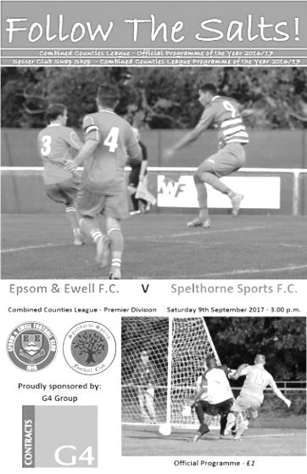
It would be very easy to look at the score of this match and combined with recent results, conclude that we were heavily beaten again. However, this match was fiercely competitive for much of the 90 minutes with exception of a 15 minute spell before half time where most of the damage was done.

Following the defeat to Redhill seven days previously we experimented with a new formation and it did appear to look more solid for much of the match. Despite the absence of Sam Robinson and Reisse Griffin and the injured Bentley Graham and Tayo Ajayi, Dan Rose and Ashley Thompson returned in midfield while Rob Hendry played his first match for a while and Joe Loftus-Cheek and Kyle Hough were both back up front. However, it was Jason Nwachukwu playing just behind them who was involved in the first chance of the match when with just 35 seconds on the clock he appeared to be sandwiched between two visiting players as the ball came into the box, but to be fair it was a bit high for all of them and a goal kick was the end result.

The first ten minutes had been fairly even but in the eleventh minute we conceded a free kick just inside our own half and the delivery was headed in by the unmarked Joe Dyett. It doesn't matter how good your formation might be, if you don't mark the opposition's big centre half at a set piece you are asking for trouble and Andy Smith in our goal had no chance.

Smith was in goal for the absent Colin Harris and like our regular keeper before him he would have a busy day on a day where occasional heavy downpours made both the surface and the ball greasy. This would prove his undoing in the 33rd minute when a low ball in from the left eluded him and was forced in at the far post by Jake Flatman with the final contact coming off one of our defenders. Unfortunately all of the bad habits now resurfaced and within a minute it was more or less game over as we lost the ball in midfield and Flatman ran in on goal from the right and drilled the ball past Smith at his near post for the third goal.

In response Scott Murphy saw his powerful strike deflected just wide of the post

before a last ditch tackle robbed Nwachukwu as he was just about to shoot but in the 43rd minute we conceded again as a low cross from the left was met with a glancing header from Turnell Sinclair which hit our far post and went in. Even the framework of the goal seems to be against us right now and as we trooped off at half time it was hard to understand how we could be four goals behind. In fact it could have been five had Smith not made a good save with his feet from a dipping long range shot just before the whistle.

There was no doubt who had been the better side in the first half, even if the score flattered them a little, but the second half was more even. We looked dangerous when Nwachukwu made a good run to set up Hough and he laid the ball to Rose but he scuffed his shot at goal from 12 yards, admittedly with his left foot. Loftus-Cheek then set up Hendry for a strike but the shot actually hit Hough who was offside and the attack was ended by the Assistant's flag.

Murphy's centre-half partner David Thomson was unfortunate to send a header wide from a decent Hendry corner after 62 minutes. Four minutes later he had another chance, although he was unable to get a good contact and the ball dribbled tamely to Brendan Hazlett in the Spelthorne goal. We were definitely starting to involve him a lot more than we had in the opening forty-five minutes.

Still there were concerns at the other end though and Murphy was well placed to head clear a dangerous right wing cross with two players waiting before a horrible challenge then came in on Thomson at knee-height, also twisting his ankle in the process. He made way for Dale Marvell soon after, while the offender only received a yellow card.

Ashley Thompson tried his luck from 25 yards forcing Hazlett into a save, while Loftus-Cheek was only just beyond the far post with a curling strike after he had beaten two players, but the visitors should have extended their lead as a good left wing cross was headed just over our bar from close range. Then with the clock showing 87 minutes a good through ball was won by Hough and although he was forced wide by the keeper, he rounded him, cut in and then shot into the goal beyond the two defenders on the line from a narrow angle as only Kyle can.

Maybe one of the most disappointing aspects of the match today was that we conceded almost immediately after scoring as Sinclair was put through after we lost the ball in the middle of the field and he finished easily past the exposed Smith. However, there were signs of progress during this match and it is hoped that we can continue to improve still further with important matches against Horley and Farnham to come.

Epsom and Ewell: Andy Smith, Ben Dyson, Rob Hendry, David Thomson, Scott Murphy, Ashley Thompson, Ben Hayward (c), Daniel Rose, Kyle Hough, Joe Loftus-Cheek, Jason Nwachukwu

Subs: Dale Marvell for Thomson (76), Liam Roberts for Thompson (80),
Sean White for Hendry (84)

#
Club Records - 12th September
Date | Day | Competition |  | Opponents |  | Scorers
12/09/25 | Sat | Surrey Senior League | A | Godalming | 3-2 | R.Marlow, J.Parr, W.Challis
12/09/31 | Sat | Surrey Charity Shield 1 | H | Carshalton Athletic | 2-1 | W.Graham, J.Meldrum
12/09/36 | Sat | London League | H | Tilbury | 7-1 | H.Pullen (5), T.Dunne (2)
12/09/53 | Sat | F.A. Cup Preliminary Round | H | Dorking | 1-1 | R.Holloway
12/09/59 | Sat | Corinthian League | H | Horsham | 2-1 | J.Sorensen (pen), S.Robertson
12/09/64 | Sat | Athenian League 1 | A | Harlow Town | 3-7 | N.Dearlove (2), T.Higgins
12/09/70 | Sat | Amateur Cup  Preliminary Round | A | Cobham | 3-1 | S.Smyth, B.Hartley (2, 1 pen)
12/09/78 | Tue | F.A. Trophy  Preliminary Round replay | A | Hounslow | 1-0 | S.Delaney
12/09/81 | Sat | Isthmian League 1 | A | Bognor Regis Town | 0-1
12/09/87 | Sat | F.A. Cup 1q | A | Molesey | 2-1 | B.Perkins, C.Holding
12/09/92 | Sat | Isthmian League 3 | H | Feltham &  Hounslow Borough | 1-1 | R.Dymond
12/09/98 | Sat | Isthmian League 3 | A | Cheshunt | 1-1 | J.Tome
12/09/00 | Tue | Isthmian League Cup 1 | A | Bedford Town | 0-1
12/09/06 | Tue | Combined Counties  Premier Division | H | Ash United | 0-3
12/09/09 | Sat | Combined Counties  Premier Division | A | Wembley | 3-1 | R.Burns, R.Bedj Bedj, M.Jarman
12/09/15 | Sat | Combined Counties  Premier Division | A | Spelthorne Sports | 6-2 | D.Cooper-Smith (2), A.McGregor, R.Hendry (2), K.Hough
Historical Decades
Date | Day | Competition |  | Opponents |  | Scorers
90 years ago – Epsom Town F.C.
10/09/27 | Sat | London League | A | Chelmsford | 1-1 | F.Watts
80 years ago – Epsom F.C.
11/09/37 | Sat | London League | H | Bostall Heath | 5-1 | B.Beglan (2), A.Griffiths, G.Collins, H.Pullen
70 years ago – Epsom F.C.
13/09/47 | Sat | London League | H | Edmonton Borough | 2-2 | W.Webber (2)
60 years ago – Epsom F.C.
14/09/57 | Sat | Corinthian League | H | Dagenham | 3-3 | J.Sorensen (2), J.Bangs
50 years ago – Epsom & Ewell F.C.
09/09/67 | Sat | Athenian League 2 | H | Aveley | 1-5 | J.Eales
40 years ago – Epsom & Ewell F.C.
10/09/77 | Sat | London Senior Cup 1q | H | Thames Polytechnic | 1-0 | T.Tuite
30 years ago – Epsom & Ewell F.C.
12/09/87 | Sat | F.A. Cup 1q | A | Molesey | 2-1 | B.Perkins, C.Holding
20 years ago – Epsom & Ewell F.C.
13/09/97 | Sat | Isthmian League 3 | H | Tring Town | 1-2 | A.Boxall
10 years ago – Epsom & Ewell F.C.
11/09/07 | Tue | Combined Counties League Cup 1 | A | North Greenford United | 3-2 | R.Burns, J.Earp (2)

History Corner – 12th September
90 years ago this week we made another long trek to Chelmsford’s New Writtle Street Ground for a London League match with mixed results, drawing 1-1. Fred Watts scored a second half equaliser and would score two even more important goals in the final match of 1927/28, but more about that later in the season.

81 years ago today Jackie Pullen scored five times in a 7-1 demolition of Tilbury in the London League at West Street. The previous season had been our worst on record to that point with a 10th place league finish, but things would improve again now and maybe unsurprisingly with Pullen, a former Tooting & Mitcham United legend up front and with players supporting him like Jimmy Jones and Welsh International Tommy Dunne who scored the other two goals that day.

We would miss out on the League title that season on goal average to Finchley, although it could have been worse as Leavesden also got 35 points from their 26 matches but finished third!

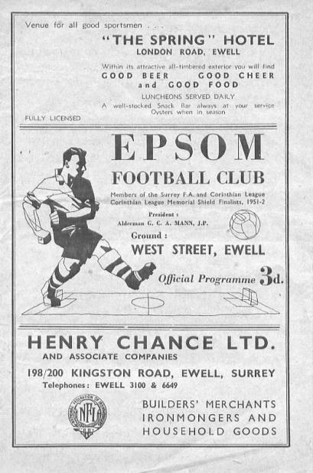
64 years ago today we hosted Dorking in the F.A. Cup at West Street but were held to a 1-1 draw, largely because of an injury to Vic Honey which left him as a passenger that day. (see programme pictured). It did have its benefit though as we became one of the first clubs to ever visit their new ground at Meadowbank for the replay, wining 1-0 in front of 1,500 spectators.

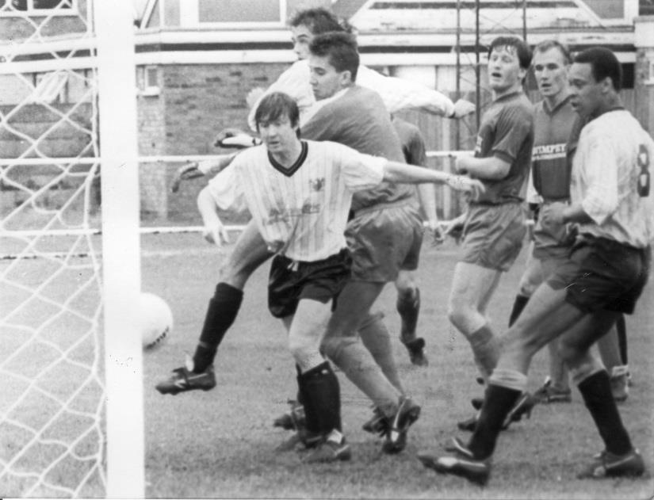
30 years ago today we visited Molesey for an F.A. Cup tie, winning 2-1 with goals from Chris Holding and Brian Perkins. However, the real story was lining up in for the opposition as this would be the first time in history that Tommy Tuite would play against us, having left the club to try his hand at coaching that season. He even won a penalty for them that day!

Centre page for results

Centre page for results

Horley Town – History
Horley Football Club first affiliated to Surrey County FA in 1896. In 1903 another local club by the name of Gatwick Rovers was formed and the two clubs merged in 1908 with Horley retaining its name. Both these original clubs played in the same colours of red and black and it was not until 1912 that Horley adopted the colours of claret and blue that they still wear to this very day. Intermediate football was tasted for the first time in season 1925/26 following an appearance in the Surrey County Junior Cup Final in 1923/24 and winning the Surrey County Junior Charity Cup in 1924/25.

Post-war Era

Following the Second World War, Horley was faced with the prospect of losing its home at “The Kings Head” ground and set about finding a new home. A local landowner by the name of Major A.L.N. Jennings became the Club’s benefactor (and President) following his generous decision to give the club 10.7 acres of land in Smallfield Road. The land was held in trust for the people of Horley from 1947, in memory of those that died in the defence of their country, and the ground was appropriately named “The Defence”.Season 1950/51 saw Horley win the Surrey Intermediate League Eastern Section and seek election to the Surrey Senior League for season 1951/52. This excursion into Senior football was short lived as the Club found themselves back in Junior football by season 1954/55. Intermediate status was regained in 1956/57 season and in season 1957/58 they entered their first ever Youth team in the local Redhill & District League.

The Seventies

With the expansion of the village to a town the Club changed its name in 1974 to become Horley Town F.C. During this spell in senior football, Horley Town enjoyed their most successful period culminating in the winning of the Surrey Senior League title and Surrey Senior League Challenge Cup in 1976/77. The Club also reached the final of the Surrey Senior League Charity Cup.

The club went on to compete in the London Spartan League and the Athenian League before returning to the Combined Counties League (formerly the Surrey Senior League).

The Modern Era

The early 1980’s saw the Club expand their interest in Youth football with the creation of Horley Town Minors. This relationship has grown over the years and is the reason why the Club has evolved into a well-respected “community club” providing football for the people of Horley irrespective of age, sex or race.In September 2003, Horley Town moved to their new ground, named “The New Defence” in deference to their old home, behind the Horley Adult Education Centre, which has now been demolished and replaced by the new Horley Leisure Centre.

The Club has been in the Combined Counties League Premier Division since 2006 and, in addition to its Reserves and Youth teams, incorporates successful junior football teams at all age levels.
In 2009/10 the Club welcomed Horley Rugby Club, and The New Defence Sports Club with its excellent facilities can now offer both sports to local enthusiasts on a regular basis.

2013/14 saw Horley Town FC appoint Ex player and club stalwart defender Anthony Jupp as manager alongside former player Chris Weller. Last season the Club had a very successful season finishing 6th in the League the highest position for years and the most ever points. The Club also had the league Top goal scorer Ashley Nadesan who scored 99 goals in the last two seasons before signing for League One side Fleetwood Town in a three year professional contract. 2015/16 was again another successful season for Town, but big changes came in the Close season with Anthony Jupp and Chris Weller standing down and experienced ex Dorking boss Glynn Stephens stepping in as manager. More work was completed on the ground with a further 52 seats fitted this time to the stand behind the goal.

Match and Ball Sponsorships – 2017/18
Opponent | Date | Match Sponsor | Ball Sponsor
Banstead Athletic (FAC) | 06/08/17 | Club President - Stella Lamont
Chertsey Town | 15/08/17 | EEFC Management Committee
Redhill | 02/09/17 | Building Shop Ltd
Spelthorne Sports | 09/09/17 | In memory of Betty Dyke
Horley Town | 12/09/17 | Alex McKay (Senior)
Hanworth Villa | 23/09/17 | Jack Jarman
North Greenford United | 28/10/17
Godalming Town | 11/11/17
Farnham Town | 14/11/17 | In memory of Dave and Lizzie Marshall
Guildford City | 02/12/17
Abbey Rangers | 16/12/17
Walton & Hersham | 30/12/17
Balham | 20/01/18
Sutton Common Rovers | 03/02/18
CB Hounslow United | 13/02/18
Knaphill | 24/02/18
Camberley Town | 10/03/18
Bedfont Sports | 24/03/18
Colliers Wood United | 30/03/18
Banstead Athletic | 02/04/18 | Nathan Lambert – 10 years old today!
Westfield | 14/04/18
AFC Hayes | 28/04/18 | Club President - Stella Lamont
F.A. Vase 1st Round Proper |  | Unknown opponents
For League, League Cup and Surrey Senior Cup Matches:
Match sponsorship - £40.00 Match ball sponsorship - £25.00. Combined £55.00.
For F.A. Cup and F.A. Vase matches:
Match sponsorship - £50.00 Match ball sponsorship - £30.00. Combined £65.00.

Sponsorship includes: (x2 for match, x3 for match and ball)

Admission, programmes, hospitality and advertising and mascot for the day (if required).
If you are interested, just speak to a Committee Member, or drop me an email at: richard.c.lambert@gmail.com

We also thank our Kit Sponsors
G4 Group

Every Opponent A-Z
Over the years we have played many, many different opponents. Exactly how many is a difficult question, as it all depends on your definition. Are Camberley & Yorktown different to Camberley Town, or are Epsom Town different to Epsom F.C. or Epsom & Ewell F.C.?

In my analysis I have classed both of the above examples as the same team, and will work through them all from A to Z. Some we have played many times, whilst others we have met just once or twice. Enjoy!

Wembley: Played 55 - W21 D14 L20 - F91 A79 - PPG - 1.40 - Average

Now I will start right now by saying that I have an issue here. Wembley FC state that they were founded in 1946. However, they appeared in the London League constitution for the ill-fated 1939/40 season, so there is an indication that they may have been around slightly earlier, even if the fates decreed that they would go into abeyance almost before they had started!

Anyway, they started to compete after the war, reaching the Delphian League fairly quickly and joining the Corinthian League for 1956/57 along with Dorking. Our first meeting in that League came on Saturday 9th February 1957 when the Lions made their inaugural visit to West Street and secured a 3-3 draw after leading by the only goal at the break. We also scored three in the return match on Wednesday evening 17th April with the home team failing to score that day, no doubt being affected by the tragic death of one of their better players Ron Clarke just one week previously.

Meetings between the clubs were fairly even for a large period of time, largely because we were of a similar standard. When we were a decent team in our League, so were they, and this was the case when we were poor too! Home advantage would also be key; in fact, we would go 46 years between wins at Vale Farm, while they would go 32 years without winning at West Street!

The 1957/58 season resulted in wins for both clubs on their home patch and whilst we were only able to take one point from the following season’s meetings, we beat them home and away in 1959/60; the second of which was a very useful 3-0 win at Vale Farm, as we returned there seven days later to win the Corinthian League Memorial Shield with a 2-0 win over Maidenhead United.

The sixties were not kind to our club, but this could also be said to be the case for Wembley as we found ourselves as the worst two teams in the Corinthian League in the years leading up to its demise in 1963 when it was merged with the Athenian and Delphian Leagues. In fact, Wembley were the only club below us in 1961/62 and 1962/63 with our boys recording another league double in the latter season, winning 6-1 on 15th May at West Street by six goals to one with Barry Sargent scoring a hat trick in the “bad winter” season.

They improved in 1963/64 but we did not, finishing bottom, but being reprieved as the Athenian League promoted a number of clubs from the lower divisions. However, our luck ran out in 1964/65 and we suffered the first relegation in our history. Even in these dire seasons we won two and drew one of the four matches against Wembley, finishing off with a 2-1 home win on 16th January 1965.

And that was it for many years until we met again in 1978/79 as members of the Isthmian League Division One. During these years we were both challenging for promotion and were very well matched with four draws in our next six meetings. In 1981/82 our two meetings came late in the season and the first of these was massively significant as a 1-0 defeat at Vale Farm would be Manager Pat O’Connell’s final match in charge before resigning.

Three more draws followed to bring us up to the 1983/84 season when we won 2-1 on the New Year’s Eve, aided by a Micky Stratford thunderbolt. In fact, we should have won the return match in April but a late equaliser secured Wembley a 1-1 draw in what was our last challenging match of the season on our way to promotion with the Lions just missing out in third place.

Of course we didn’t spend long at the higher level and we met again back in Division One in 1986/87, drawing 1-1 on the opening day of the season but losing 3-2 at Wembley in January 1987 on a day when Mark Norman scored his one and only goal for the first team. Unfortunately, despite facing ten men for the entire second half we were unable to force an equaliser and although we fought hard for the remainder of the season we suffered a second straight relegation.

We dropped into the Isthmian League Division Three after a while and they remained two flights above us and easily won our next meeting 3-1 in the FA Cup in August 1994, by now at Merland Rise. This was their first away win since 1962, and we wouldn’t meet for ten more years until both clubs found themselves in the Isthmian League Division Two.

They finally recorded their first ever double over us in 2005/06 with the first match occurring on 26th November 2005 which was marked by a minute’s applause in memory of George Best. We were dreadful that year and when both of us were transferred into the Combined Counties League in 2006 we were no better, conceding two goals in the last two minutes to lose 2-3 at home in Pater Augustine’s final match as Caretaker / Manager and 5-0 at Wembley in a match spoilt by the early sending off of Oliver Dicks. A loss and a draw followed in 2007/08.

We were improving though and on an incredible evening on 28th October 2008 the snow fell and the Divali fireworks flashed all around as we won 5-0 there to go top of the League table for the first time in years. It was our first win at Vale Farm since 1962 and we were able to repeat the victory on our next two visits also, although we would lose both home League matches.

In 2011/12 we lost 4-1 on a very windy day at Vale Farm before defeating them 1-0 at Merstham in a match where one of our supporters John Bonner took over the flag, following an injury to one of the match officials. Since then we have met them a couple of times at Chipstead, winning once and losing once and winning twice, 4-1 and 3-1 at Vale Farm. Our final meeting came in a League Cup Q-F there on 18th March 2014 and we didn’t really turn up, losing 2-0 to release our hold on the Cup we had won the previous year. It was a long trek around the M25 for a midweek fixture and in 2014 the F.A. moved them into the South Midlands League where they remain to this day.

Below: Vale Farm’s new stand which replaced the fire damaged one on the other side

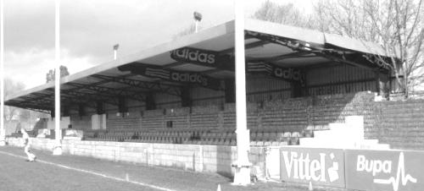

Combined Counties League Premier Division
Opponents All-time Records
inc Saturday 9th Sept | P | W | D | L | F | A | PPG | GD | Best  Win | Worst  Loss
Godalming Town | 1 | 1 | 0 | 0 | 2 | 1 | 3.00 | +1 | 2-1 | X
Horley Town | 30 | 21 | 5 | 4 | 67 | 31 | 2.27 | +36 | 6-0 | 1-3
Abbey Rangers | 4 | 3 | 0 | 1 | 11 | 4 | 2.25 | +7 | 7-1 | 2-3
Sutton Common Rovers | 13 | 9 | 2 | 2 | 30 | 19 | 2.23 | +11 | 4-0 | 0-5
Spelthorne Sports* | 8 | 5 | 2 | 1 | 16 | 11 | 2.13 | +5 | 6-2 | 1-5
Bedfont Sports | 11 | 7 | 2 | 2 | 21 | 12 | 2.09 | +9 | 5-1 | 0-4
Banstead Athletic | 38 | 23 | 7 | 8 | 62 | 38 | 2.00 | +24 | 5-0 | 0-4
Knaphill | 8 | 5 | 1 | 2 | 17 | 9 | 2.00 | +8 | 4-0 | 1-2
Guildford City | 18 | 11 | 1 | 6 | 35 | 22 | 1.89 | +13 | 5-1 | 1-5
Westfield | 21 | 12 | 3 | 6 | 43 | 36 | 1.86 | +7 | 6-1 | 0-4
Colliers Wood United | 24 | 14 | 2 | 8 | 47 | 39 | 1.83 | +8 | 4-0 | 0-5
Farnham Town | 15 | 8 | 3 | 4 | 27 | 25 | 1.80 | +2 | 3-1 | 1-4
Hanworth Villa | 17 | 8 | 4 | 5 | 38 | 27 | 1.65 | +11 | 5-0 | 1-4
Walton & Hersham | 52 | 25 | 11 | 16 | 105 | 99 | 1.65 | +6 | 8-0 | 1-9
Camberley Town* | 90 | 38 | 22 | 29 | 158 | 125 | 1.51 | +33 | 9-1 | 0-4
Redhill | 34 | 14 | 2 | 18 | 63 | 74 | 1.29 | -11 | 7-2 | 2-8
Chertsey Town | 50 | 19 | 5 | 26 | 77 | 94 | 1.24 | -17 | 3-0 | 0-7
North Greenford United | 12 | 4 | 2 | 6 | 18 | 22 | 1.16 | -4 | 3-0 | 1-4
AFC Hayes | 10 | 2 | 3 | 5 | 18 | 18 | 0.90 | 0 | 7-0 | 0-3
CB Hounslow United | 4 | 1 | 0 | 3 | 6 | 11 | 0.75 | -5 | 2-0 | 1-5
Balham | - | - | - | - | - | - | - | - | - | -
* includes one abandoned match v Camberley and one loss on penalties v Spelthorne

Salts Super Six Predictor
The Salts Super Six Predictor is live again today and the tickets are on sale at today’s game to the left of the gate. The matches are to be played on Saturday.

The jackpot is now up to £479 which if won would represent the largest individual prize so far and who knows how much higher it could rise!

The competition is easy to play! To win, you simply need to predict the results of six matches correctly from the three options, fill in the form and make sure it is back with our seller before the deadline on the ticket. The latest fixtures are shown below.

If you are a club regular, you just need to place your name on the sheet, although if you aren’t, then we’ll need a contact number from you too. We will announce any winners on the website within three working days, so don’t worry, we won’t miss you!

Please note that if there is more than one winner, the prize pot would be shared between the winners. All you need to do now is have a go, as many times as you like!

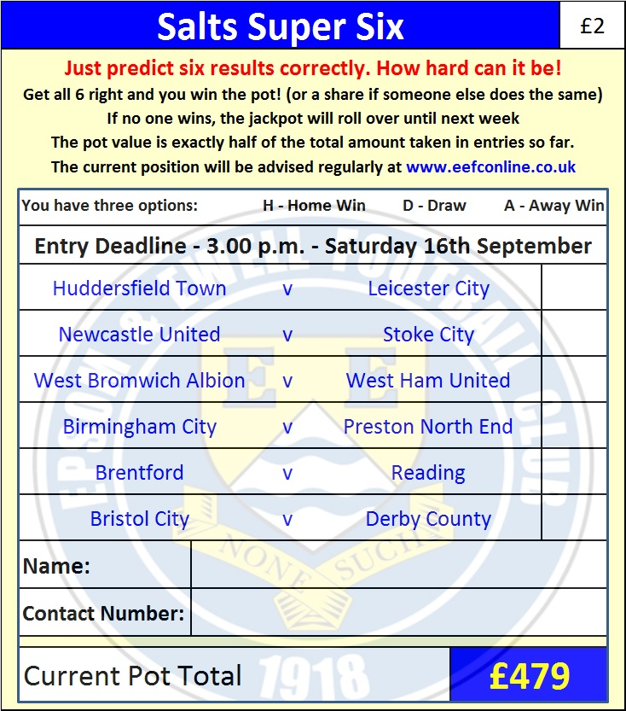

Good luck!

Combined Counties League – Premier Division
Tuesday, 12th September 2017 - Kick-off 7.45 p.m.
Epsom and Ewell  (Royal Blue & White hoops) | V |  | Horley Town  (White / Black)
Squad | NUMBERS |  | Squad
Colin Harris |  |  | George Hyde
Reisse Griffin |  |  | Andrew Osai
Ben Dyson |  |  | Scott Robson
David Thomson |  |  | Ryan Brackpool
Scott Murphy |  |  | Liam Cox
Louis O’Brien |  |  | Jack Poplett
Ben Hayward |  |  | Ben Herdman
© Sam Robinson |  |  | Alex Barbary
Kyle Hough |  |  | Ryan Smith ©
Joe Loftus-Cheek |  |  | Conrae Cespedes
Rob Hendry |  |  | Tate Greenaway
Dale Marvell |  |  | Ayden Richards
Daniel Rose |  |  | Mark Bevan
Antony ‘Freddy’ Myers |  |  | Kerran Boylan
Jason Nwachukwu |  |  | Adam Grant
Jordan Brooks |  |  | Zach Powell
Sean White
Liam Roberts
Tayo Ajayi
Ali Dewar
Tom Harland-Goddard
Alistair Turpie
Ashley Thompson
Andy Smith
Glyn Mandeville | MANAGER |  | Glynn Stephens
Matt Smith | ASSISTANT |  | Steve Hurd / Brett Rhoades
Alex McKay / Jimmy Hendry | COACHES / PHYSIO |  | Matt Chapman / Steve Rogers
REFEREE: M.Edwards
ASSISTANTS: N.Dovrat, A.Merchant
Today’s Match and Match Ball are kindly sponsored by:
Alex McKay (senior)

OUR NEXT VISITORS TO HIGH ROAD
Hanworth Villa
Cherry Red Combined Counties League – Premier Division
Saturday 23rd September 2017 – 3.00 p.m.

